LEARNING OBJECTIVES
LO 1-1 Identify typical misconceptions about marketing, why they persist, and the resulting challenges for marketing management.
LO 1-2 Define what marketing and marketing management really are and how they contribute to a firm’s success.
LO 1-3 Appreciate how marketing has evolved from its early roots to be practiced as it is today.
LO 1-4 Recognize the impact of key change drivers on the future of marketing.

Chapter Outline
- WELCOME TO MARKETING MANAGEMENT | 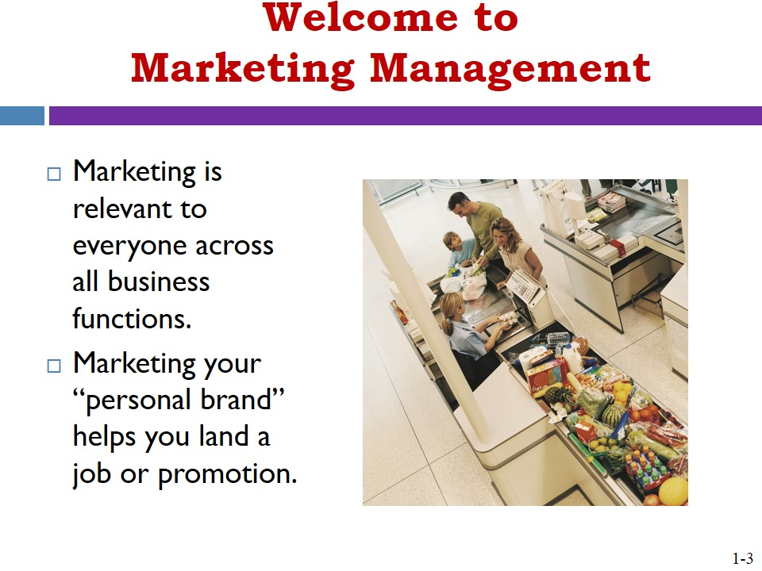
- MARKETING MISCONCEPTIONS | 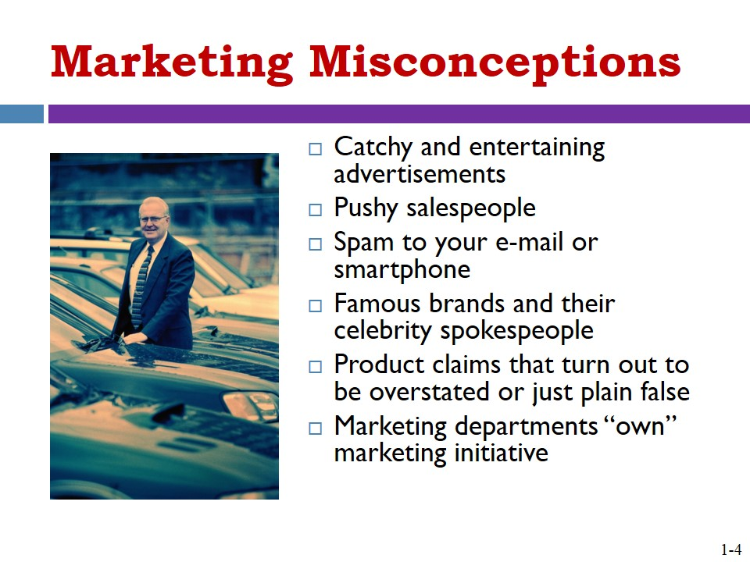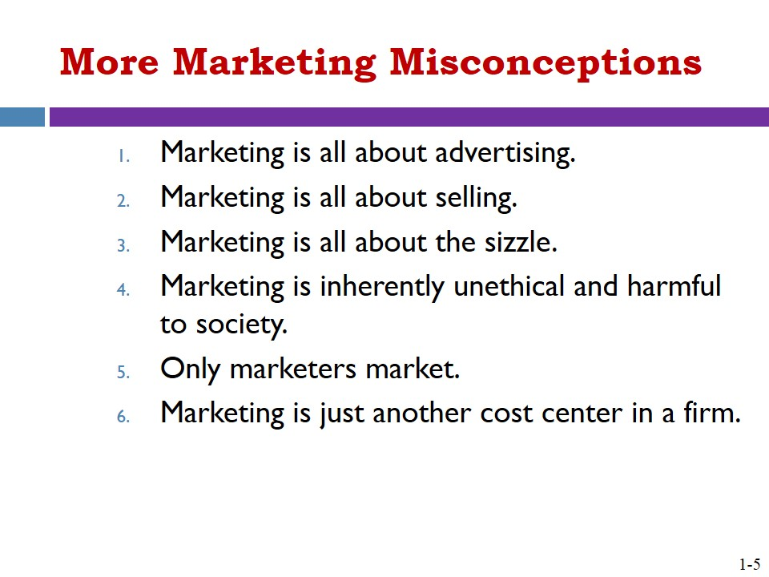
- Behind the Misconceptions  - Marketing is Highly Visible by Nature  - Marketing is More Than Buzzwords | 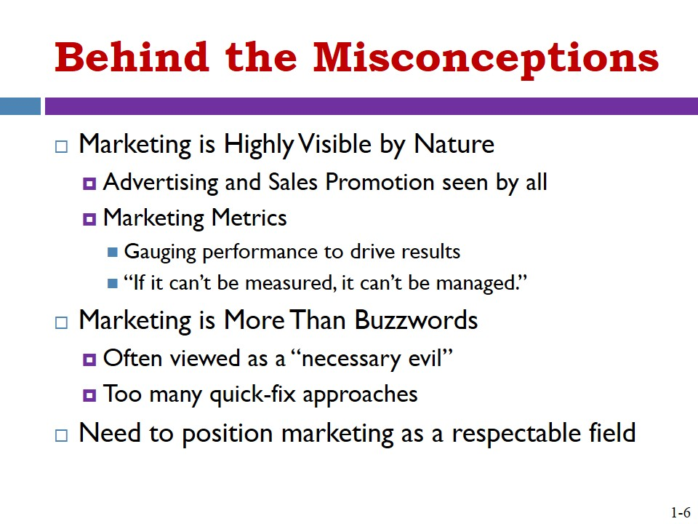
- Beyond the Misconceptions and Toward the Reality of Modern Marketing | 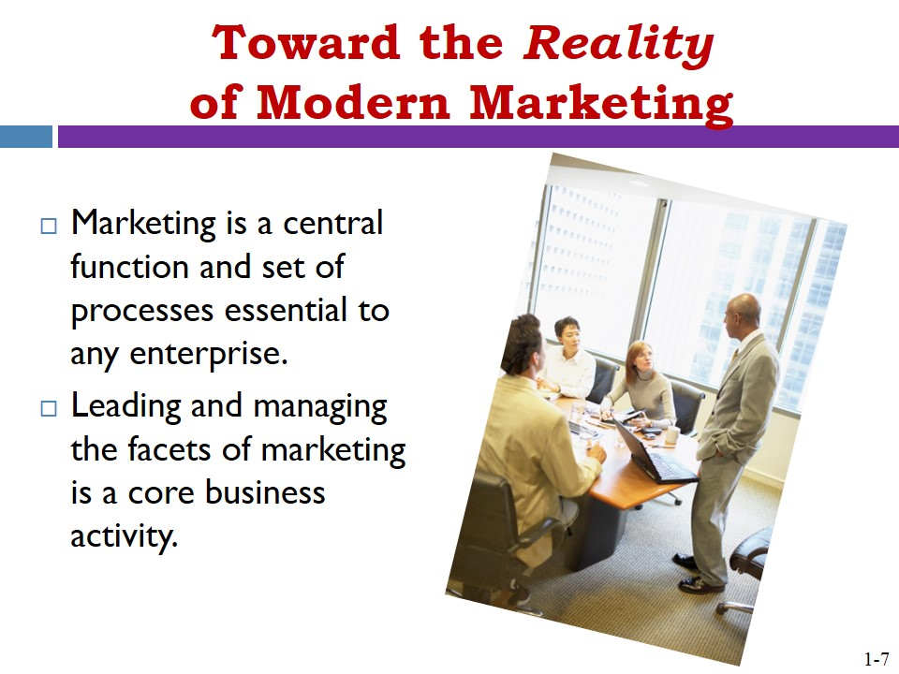
- DEFINING MARKETING | 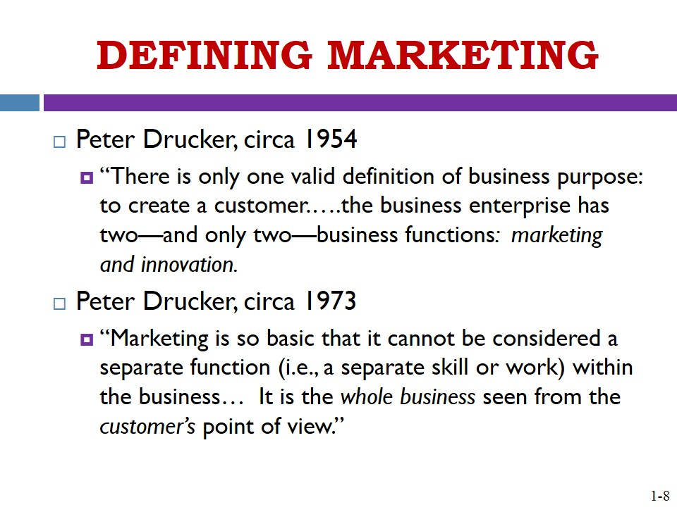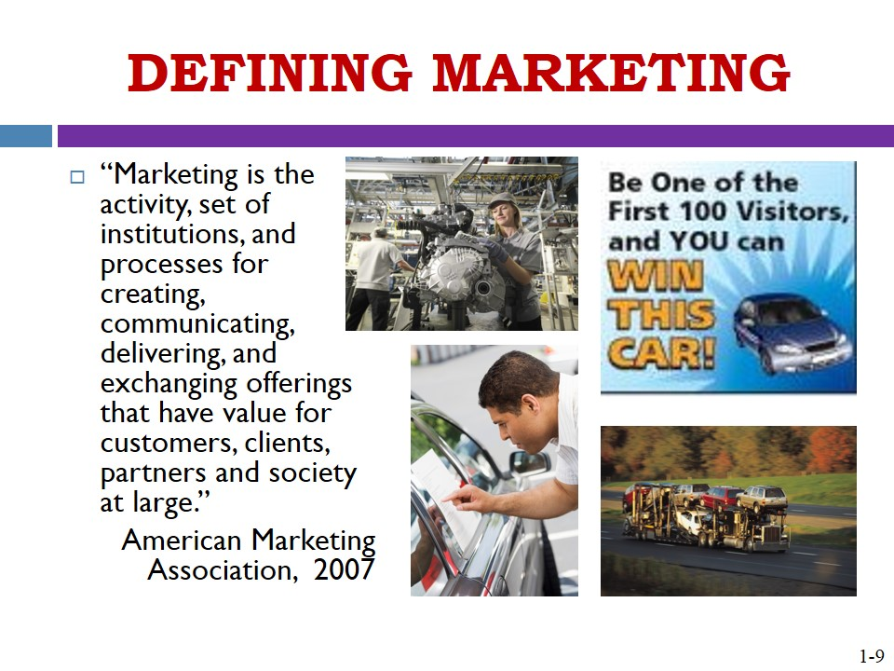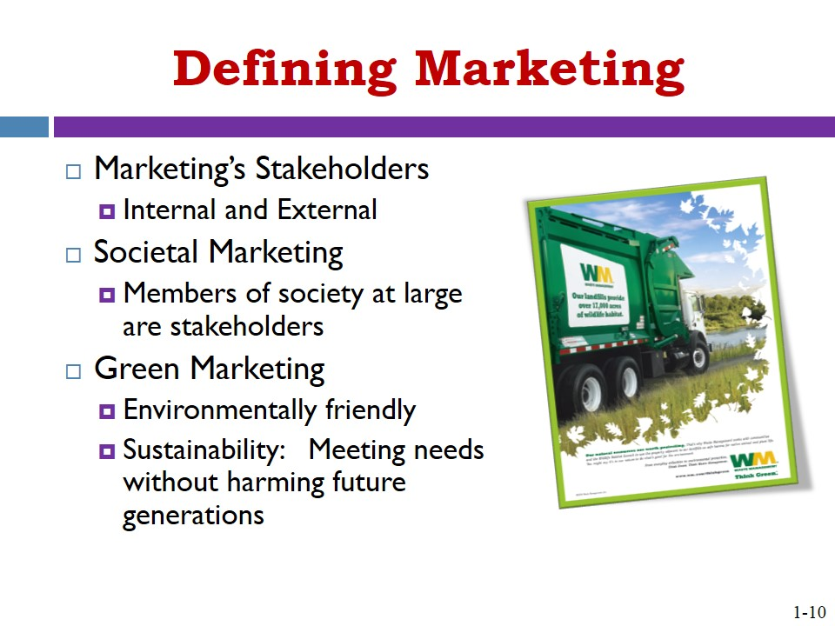
- Value and Exchange are Core Marketing Concepts | 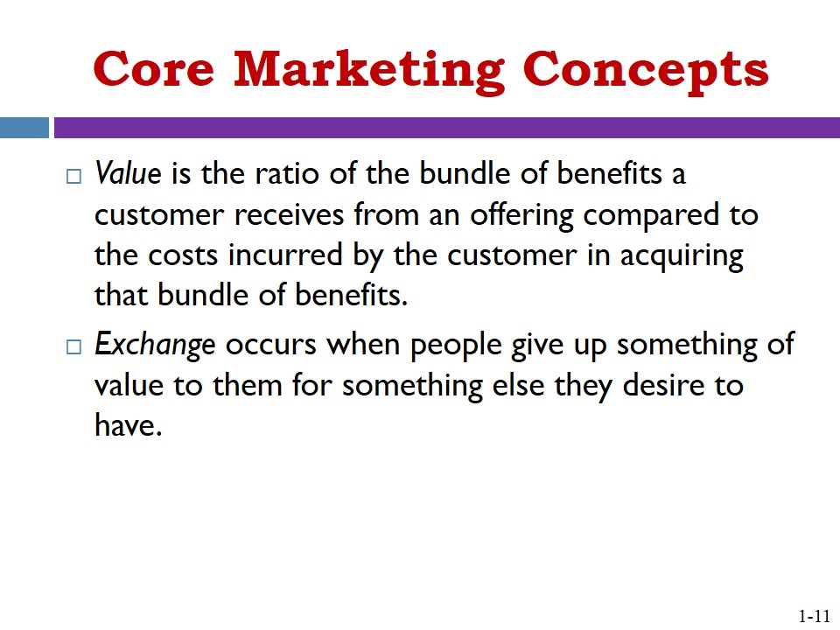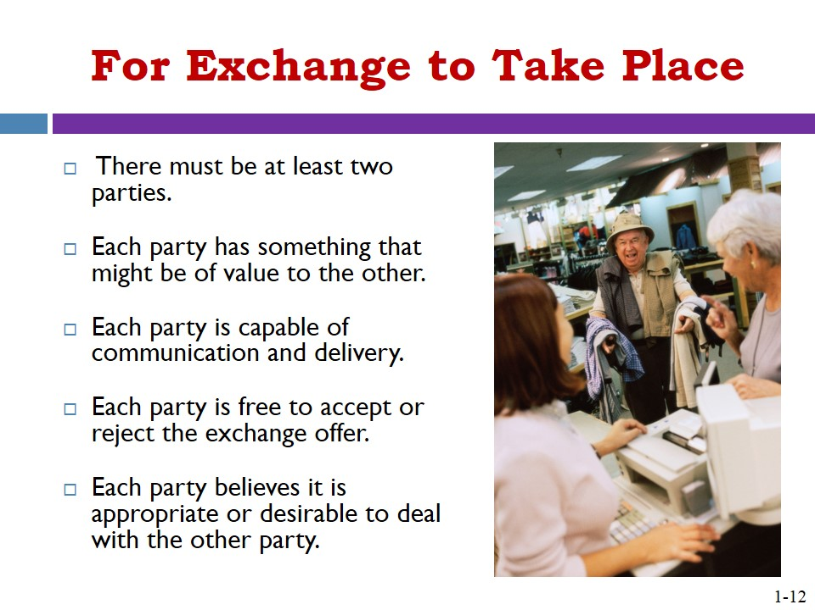
- MARKETING’S ROOTS AND EVOLUTION  - Pre-Industrial Revolution  - Focus on Production and Products  - Focus on Selling  - Advent of the Marketing Concept  - The Marketing Mix | 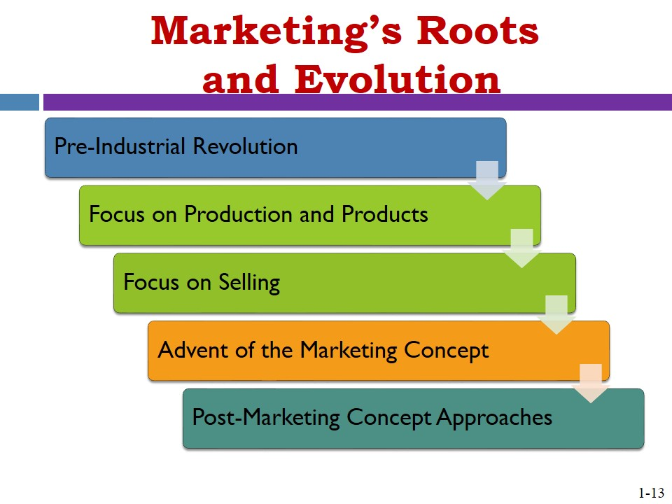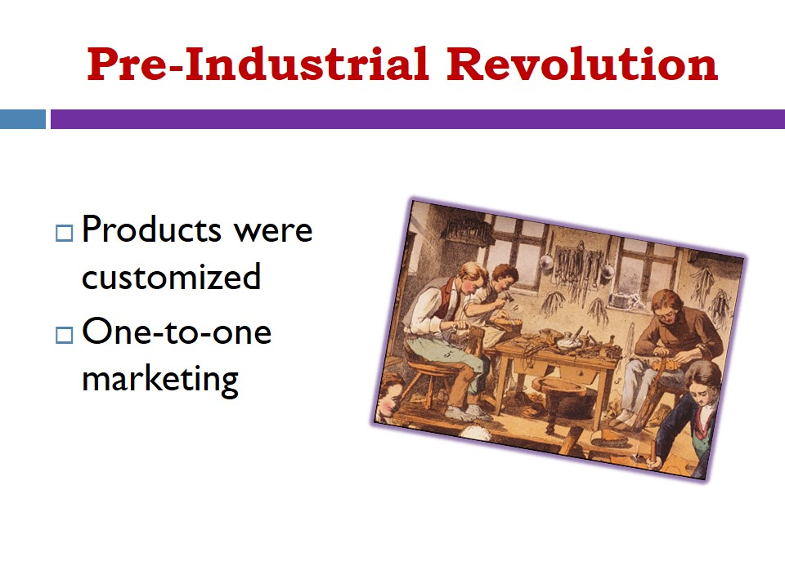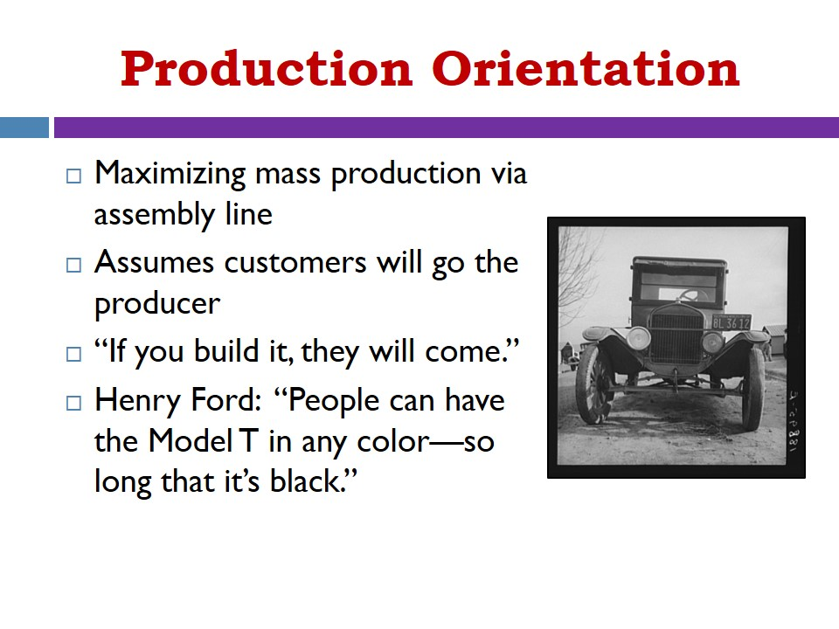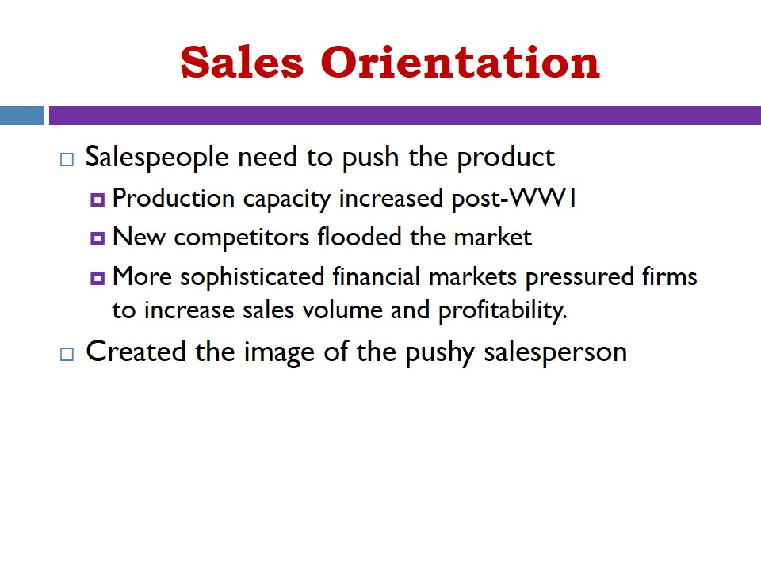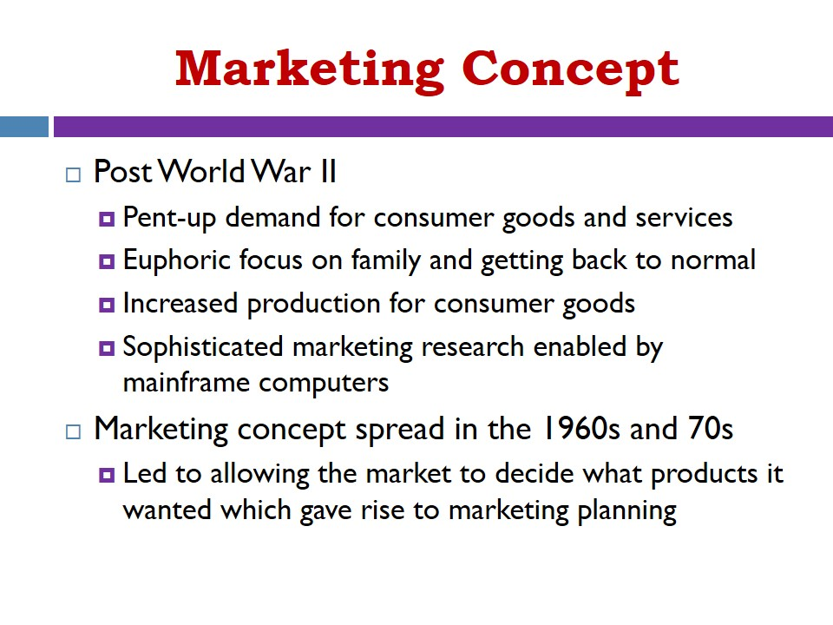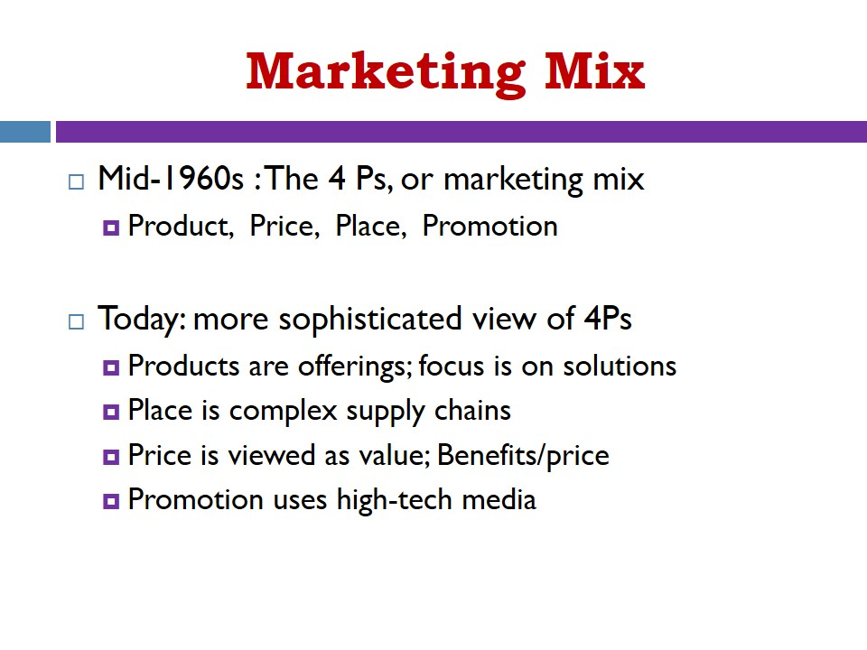
- Beyond the Marketing Concept  - Differentiation Orientation  - Market Orientation  - Relationship Orientation  - One-to-One Marketing | 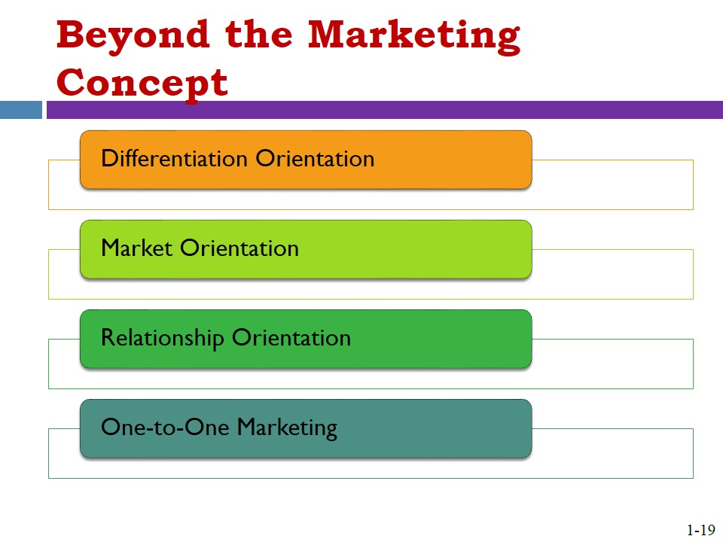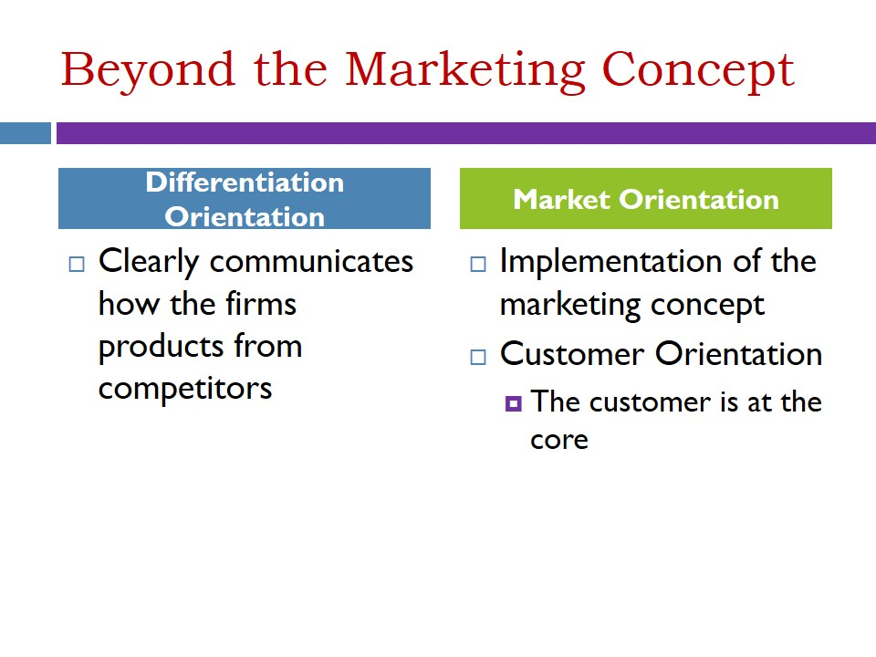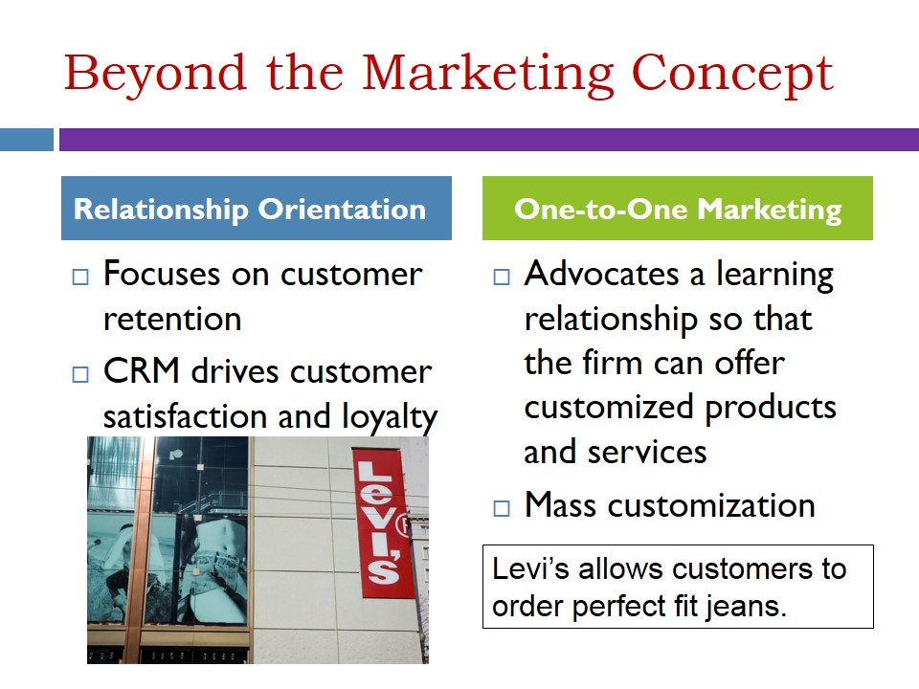
- CHANGE DRIVERS IMPACTING THE FUTURE OF MARKETING | 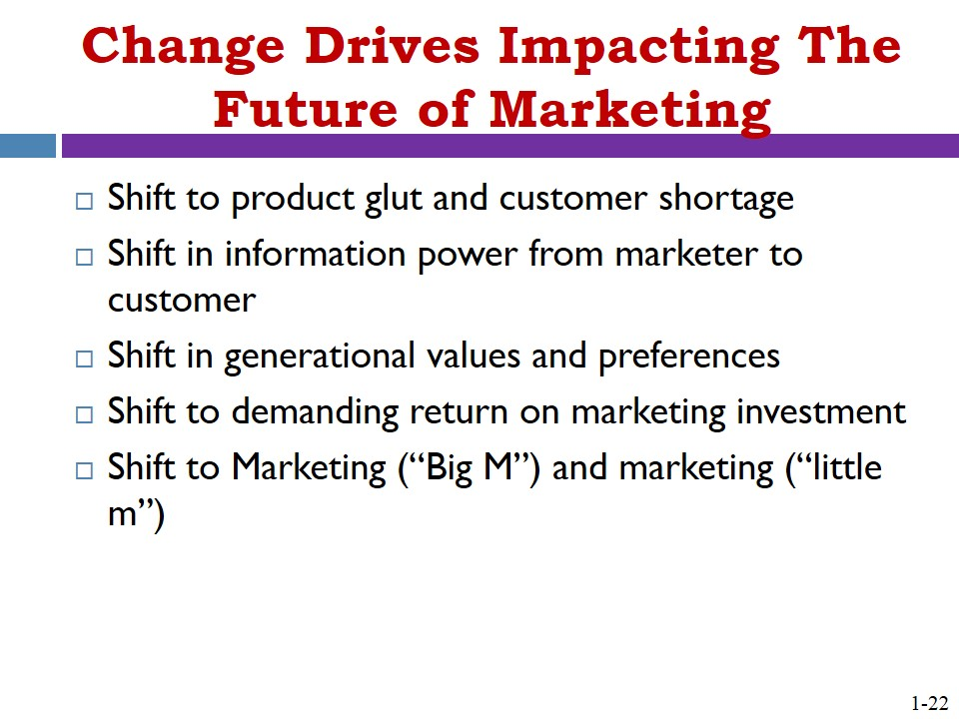
- Shift to Product Glut and Customer Shortage | 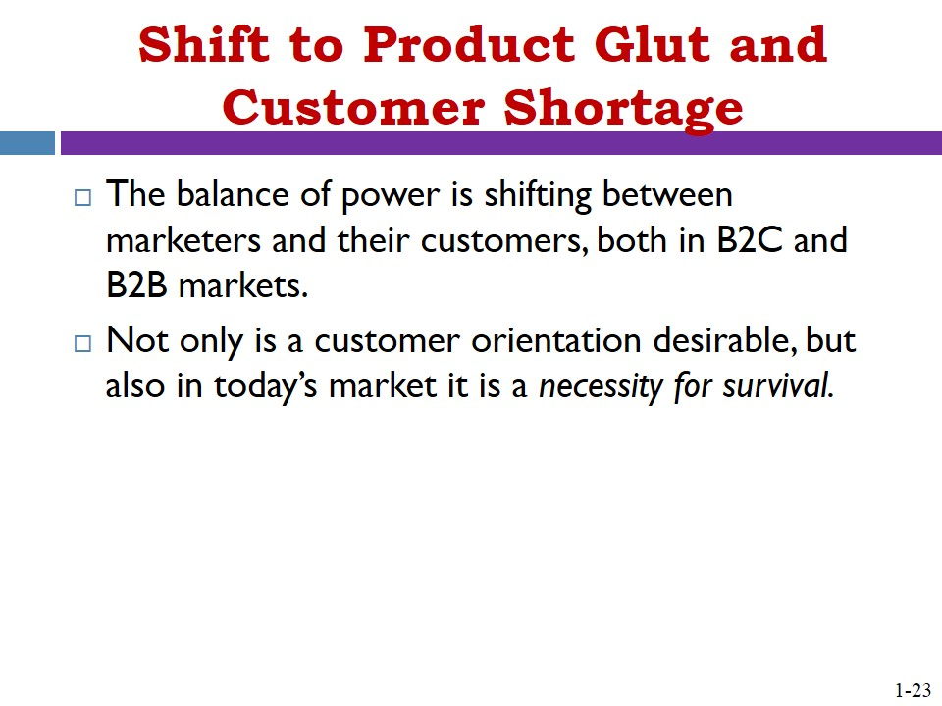
- Shift in Information Power from Marketer to Customer | 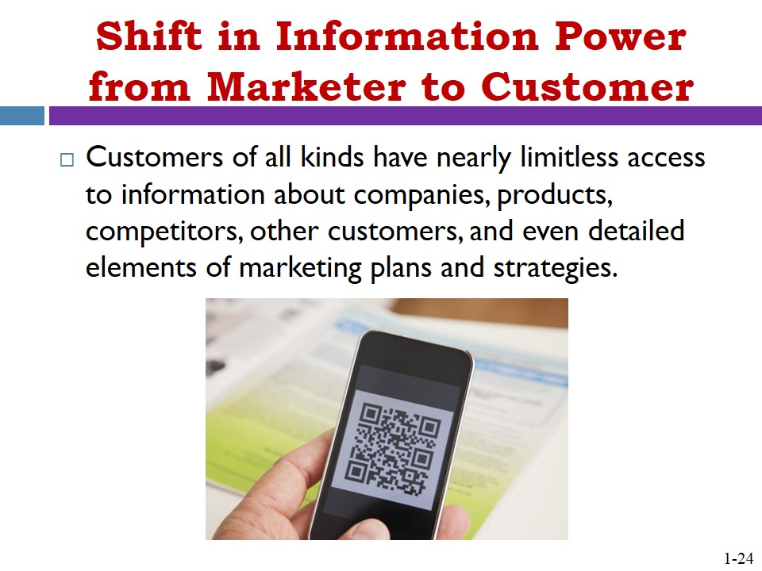
- Shift in Generational Values and Preferences | 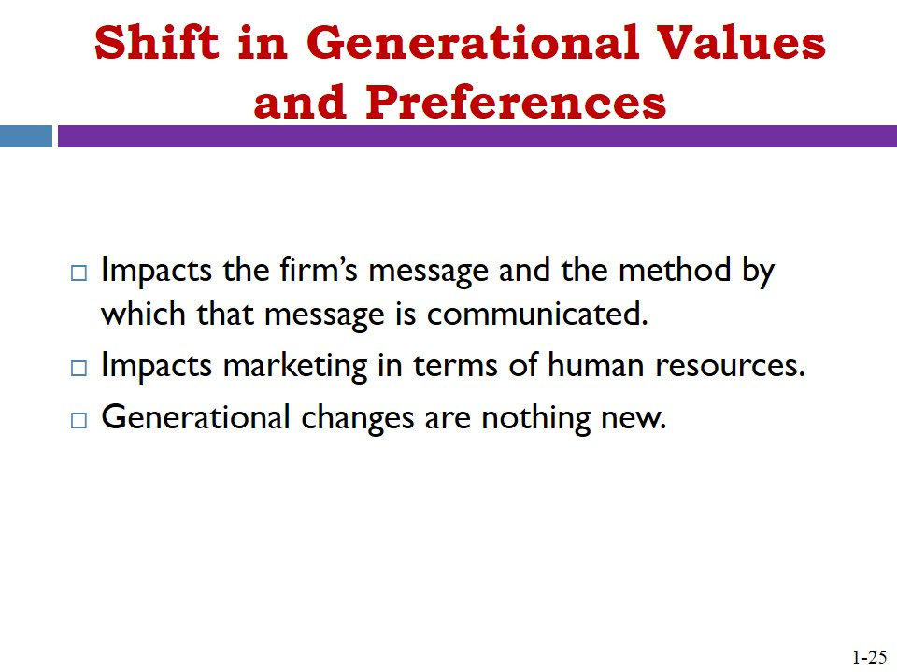
- Shift to Distinguishing Marketing (Big M) from marketing (little m)  - Marketing (Big M)  - marketing (little m) | 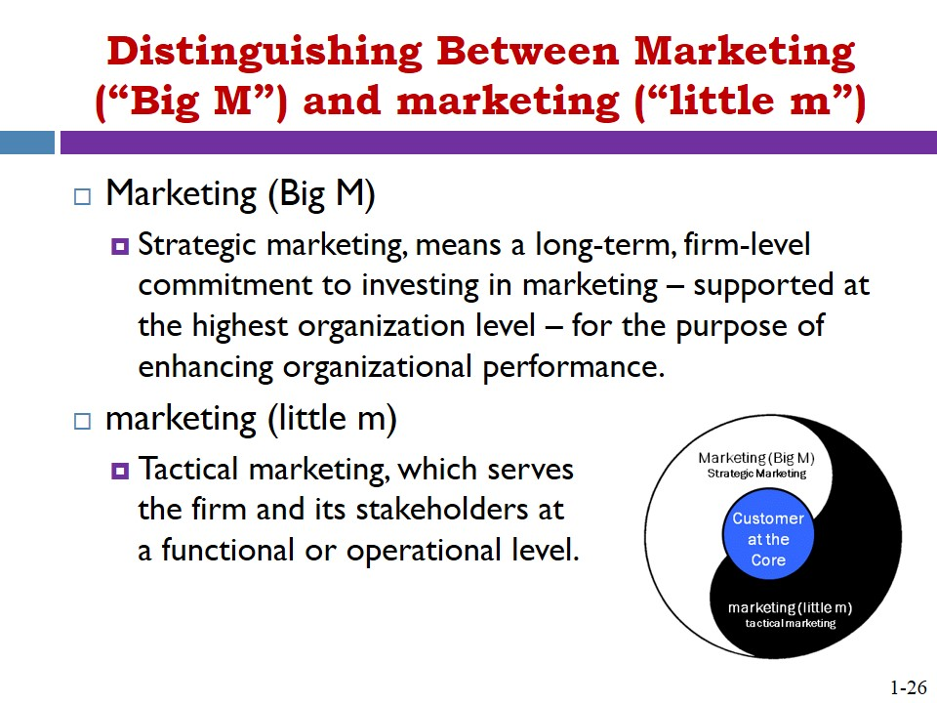
- Shift to Justifying the Relevance and Payback of the Marketing Investment | 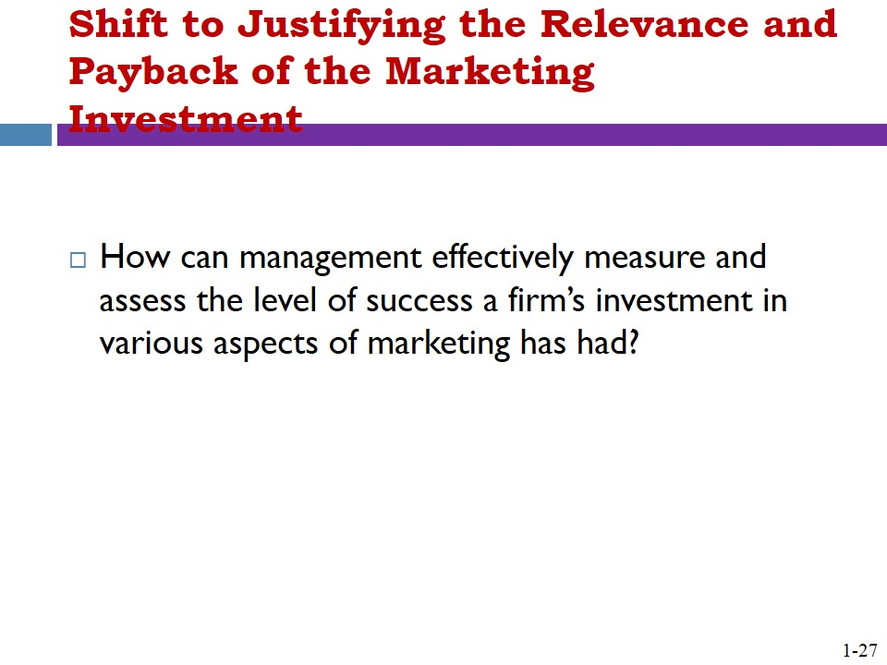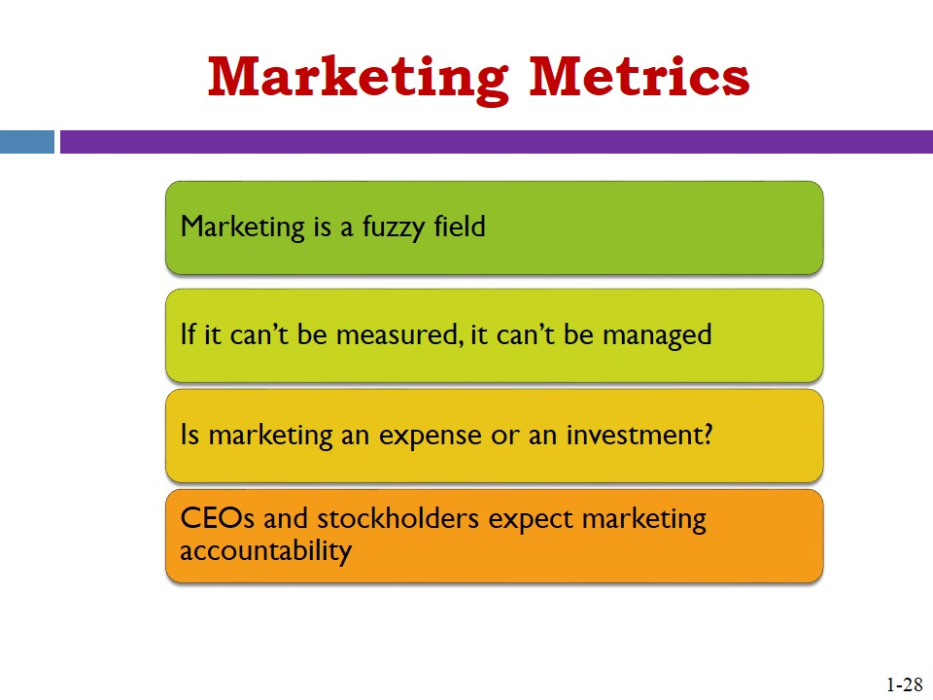
- YOUR MARKETING MANAGEMENT JOURNEY BEGINS
- SUMMARY

ETHICAL DIMENSION 1
Ethical Perspective
- Nike: How would you prioritize what are often two conflicting demands: consumer product performance expectations and the demand for ecofriendly products?
Nike has proven that you can focus on both objectives, and still achieve competitive results. However, profit responsibilities should have long-term priority. If Nike cannot earn the profits necessary to remain in business, then it will not be able to continue to contribute to society.

- Consumers: Would you choose a Nike shoe that provided less comfort but was more environmentally friendly? Would you pay a premium for an environmentally friendly Nike shoe?
Consumers are a diverse group representing a variety of preferences. There are customers that value comfort and style over environmentally sensitive products and vice versa.

- Environmental groups: Nike took almost two decades to create a new sole for its air cushion; would you allow a company that much time to deal with an environmentally damaging product?
Companies must have the support from their stakeholders to innovate environmentally sensitive products. However, innovation cannot be placed on a timetable and this complicates the issue.

KEY TERMS
marketing management The leading and managing of the facets of marketing to improve individual, unit, and organizational performance.
marketing’s stakeholders Any person or entity inside or outside a firm with whom marketing interacts, impacts, and is impacted by.
societal marketing The concept that, at the broadest level, members of society at large can be viewed as a stakeholder for marketing.
sustainability The practicing of business that meets humanity’s needs without harming future generations.
value A ratio of the bundle of benefits a customer receives from an offering compared to the costs incurred by the customer in acquiring that bundle of benefits.
exchange The giving up of something of value for something desired.
production orientation The maximization of production capacity through improvements in products and production activities without much regard for what is going on in the marketplace.
sales orientation The increase of sales and consequently production capacity utilization by having salespeople “push” product into the hands of customers.
marketing concept Business philosophy that emphasizes an organization-wide customer orientation with the objective of achieving long-run profits.
marketing mix (4Ps of marketing) Product, price, place, and promotion—the fundamental elements that comprise the marketer’s tool kit that can be developed in unique combinations to set the product or brand apart from the competition.
customer-centric Placing the customer at the core of the enterprise and focusing on investments in customers over the long term.
differentiation The target marketing approach that involves developing different value offerings for different targeted segments.
market orientation The implementation of the marketing concept, based on the understanding of competitors and listening to the market.
customer orientation Placing the customer at the core of all aspects of the enterprise.
relationship orientation Investing in keeping and cultivating profitable current customers instead of constantly having to invest in gaining new ones.
one-to-one marketing Directing energy and resources into establishing a learning relationship with each customer and connecting that knowledge with the firm’s production and service capabilities to fulfill that customer’s needs in as custom a manner as possible.
mass customization Combining flexible manufacturing with flexible marketing to greatly enhance customer choice.
Marketing (big M) The dimension of marketing that focuses on external forces that affect the organization and serves as the driver of business strategy.
strategic marketing The long-term, firm-level commitment to investing in marketing—supported at the highest organization level—for the purpose of enhancing organizational performance.
market creation Approaches that drive the market toward fulfilling a whole new set of needs that customers did not realize was possible or feasible before.
marketing (little m) The dimension of marketing that focuses on the functional or operational level of the organization.
tactical marketing Marketing activities that take place at the functional or operational level of a firm.
marketing metrics Tools and processes designed to identify, track, evaluate, and provide key benchmarks for improvement of marketing activities.

APPLICATION QUESTIONS
- Consider the various marketing misconceptions introduced in this chapter.
  - Pick any two of the misconceptions and develop a specific example of each from your own experience with firms and brands.
• Catchy and entertaining advertisements — or perhaps the opposite, incessant and boring advertisements.
- Pushy salespeople trying to persuade someone to buy it right now.
- Famous brands and their celebrity spokespeople, such as Nike’s athlete endorsers.
- Product claims that turn out to be overstated or just plain false, causing doubt about the trustworthiness of a company.
- Marketing departments “own” an organization’s marketing initiative.
  - How will it be beneficial for a new marketing manager to understand the misconceptions that exist about marketing?
Effective marketing management isn’t about buzzwords or quick fixes. In today’s business milieu, the reality of marketing is that it is a central function and set of processes essential to any enterprise. Moreover, leading and managing the facets of marketing in order to improve individual, unit, and organizational performance – marketing management – is a core business activity, worthy of any student’s study and mastery.
  - Can you come up with some other marketing misconceptions of your own – ones that are not addressed in the chapter?
Student answers to this question will vary.

- In the chapter we make a strong case for the relevance of Peter Drucker’s key themes today, even though much of his writing was done decades ago. Do you agree that his message was ahead of its time and is still relevant? Why or why not? Assume you are the CEO of a firm that wants to practice a market orientation. How will Drucker’s advice help you to accomplish this goal?
Peter Drucker’s key themes included a business built around the customer with resources and processes aligned to maximize customer value. He also believed that marketing is the central core of the firm, and it should therefore be the concern and responsibility of the entire organization. This business philosophy was well ahead of its time.
Excerpts from Drucker’s advice that would impact an executives’ effort to enact a market orientation:
What the customer thinks he is buying, what he considers “value” is decisive…Because it is the [purpose of a business] to create a customer, [the] business enterprise has two – and only two – business functions: marketing and innovation.

- Put yourself in the role of a marketing manager – from this perspective, do you agree with the concepts of societal marketing and sustainability? Why or why not? How does a focus on sustainability affect the marketing manager’s role and activities? Identify two organizations that you believe do a great job of paying attention to sustainability and present the evidence that leads you to this conclusion.
Marketing’s stakeholders include any person or entity inside or outside a firm with whom marketing interacts, impacts, and is impacted by. At the broadest conceptual level, members of society at large can be viewed as a stakeholder for marketing – a concept called societal marketing.
Sustainability refers to business practices that meet humanity’s needs without harming future generations.
Sustainability practices have helped socially responsible organizations incorporate doing well by doing good into their overarching business models so that both the success of the firm and the success of society at large are sustained over the long term.
Example of an organization that is doing a great job of paying attention to sustainability:
Unilever,
- In Brazil, the company operates a free community laundry in a São Paulo slum, provides financing to help tomato growers convert to eco-friendly “drip” irrigation, and recycles 17 tons of waste annually at a toothpaste factory.
- Unilever funds a floating hospital that offers free medical care in Bangladesh, a nation with just 20 doctors for every 10,000 people.
- In Ghana, it teaches palm oil producers to reuse plant waste while providing potable water to deprived communities.
- In India, Unilever employees help thousands of women in remote villages start micro-enterprises.
- Responding to green activists, the company discloses how much carbon dioxide and hazardous waste its factories discharge around the world.

- Review the section on change drivers and select any two within the set that you want to focus on. Pick an organization of your choice and answer the following questions:
a. In what ways do each of the change drivers impact the firm’s ability to successfully do marketing?
b. How is the firm responding to the change drivers in the way it approaches its business? What should it be doing that it is not doing at present?
c. What role do you believe the marketing manager has in proactively preparing for these and future change drivers?
Students will provide various answers. Here is information that should be used to inform their responses:
Five key areas of shift, or change drivers, are:
- Shift to product glut and customer shortage.
- Shift in information power from marketer to customer.
- Shift in generational values and preferences.
- Shift to demanding return on marketing investment.
- Shift to distinguishing Marketing (“Big M”) from marketing (“little m”).

- In the chapter you learned that harmonious performance of Marketing (big M) and marketing (little m) within a firm can lead to greater levels of success. Why is this true? What does it mean that these two need to be “harmonious?” What would be some likely negative consequences they were out of sync?
Specific programs and tactics aimed at customers and other stakeholder groups tend to emanate from marketing (little m). However, marketing (little m) always needs to be couched within the philosophy, culture, and strategies of the firm’s Marketing (Big M). Based on these statements, those firms that are successful at accomplishing “little m” goals and objectives will inherently be well on their way to doing the same with “Big M” goals and objectives.
Marketing (Big M) and marketing (little m) should be quite naturally connected within a firm, as the latter tends to represent the day-to-day operationalization and implementation of the former. If they were to become out of sync, the consequences could lead to confusion within the firm (internal), confusion in the marketplace with customers (external), and possible underachievement in terms of overall strategy goals.

MANAGEMENT DECISION CASE: Gaining a Foothold Amongst Giants While Being KIND
Questions for Consideration:
- What other aspects of the AMA definition of marketing might KIND exploit in the future to continue to grow its business?
The American Marketing Association offers the following as its official definition of marketing:
Marketing is the activity, set of institutions, and processes for creating, communicating, delivering, and exchanging offerings that have value for customers, clients, partners, and society at large.
An example could be that KIND begins a campaign with its supply chain partners to promote the green aspects of its manufacturing process and reduce the cost of its’ ingredients thereby creating even more value for its customer.

- Do you think consumers supporting brands and companies that strive to benefit society are a trend that will continue? Why or why not?
“Purpose Marketing, or “Pro-Social Marketing,” is growing as a marketing strategy. This growing popularity can be attributed to an increasing number of consumers who say what a company stands for influences their purchasing decisions.

- What other industries might be especially prone to entry by a smaller, more nimble, and more socially conscious competition? What are the prospects for a competitor being successful in those industries?
An example of this can be seen in the auto industry. Tesla Motors a company that designs, manufactures, and sells electric cars and electric vehicle powertrain components. The company is attempting to exploit the unfulfilled market for automobiles that are easier on the environment.

Peter F. Drucker, The Practice of Management. New York: Harper and Row, 1954 pp. 37-38.
John Grant, “Green Marketing,” Strategic Direction, Vol. 24, Iss. 6, 2008 pp. 25-27.
Marco Vriens, “Strategic Research Design,” Marketing Research, Vol. 15, Iss. 4, 2003, p. 20.

